Experiment No: 1

Title: Demonstrate inline, internal, and external CSS and JavaScript; use console methods; create a webpage showing user info and a welcome message.

Software/Tools Required: Visual Studio Code (or any text editor), Web Browser (Google Chrome, Microsoft Edge, Firefox, etc.)

Code:
<!DOCTYPE html>
<html lang="en">
<head>
<meta charset="UTF-8">
<meta name="viewport" content="width=device-width, initial-scale=1.0">
<title>Experiment 1: Master CSS & JS Integration</title>

<link rel="stylesheet" href="style.css">

<style>
body {
background-color: #faf9f6; /* Aesthetic soft beige background */
font-family: 'Segoe UI', Tahoma, Geneva, Verdana, sans-serif;
color: #333;
margin: 0;
padding: 40px 20px;
}

.header-section {
text-align: center;
margin-bottom: 40px;
}

/* Horizontal Alignment using Flexbox */
.container {
display: flex;
flex-direction: row;
justify-content: center;
gap: 25px;
width: 100%;
max-width: 1300px;
margin: 0 auto;
}

.card {
background: #ffffff;
border-radius: 12px;
padding: 25px;
box-shadow: 0 4px 12px rgba(0,0,0,0.04);
border-left: 5px solid #d4c4b7;
flex: 1; /* Makes all three cards take equal horizontal space */
display: flex;
flex-direction: column;
}

.card h3 {
margin-top: 0;
color: #4a4a4a;
font-size: 1.1em;
margin-bottom: 10px;
}

.card p {
font-size: 0.9em;
color: #555;
flex-grow: 1; /* Pushes buttons to the bottom evenly */
}

.section-tag {
font-size: 0.8em;
text-transform: uppercase;
letter-spacing: 1px;
color: #8c7a6b;
font-weight: bold;
margin-bottom: 5px;
}

button {
background-color: #8c7a6b;
color: white;
border: none;
padding: 10px 15px;
border-radius: 6px;
cursor: pointer;
font-size: 0.9em;
margin-top: 10px;
width: 100%; /* Full width buttons for cleaner look in narrow cards */
transition: background 0.3s ease;
}

button:hover {
background-color: #6b5a4d;
}

.display-box {
margin-top: 15px;
padding: 15px;
background-color: #f4f1ea;
border: 1px solid #e0dcd3;
border-radius: 6px;
display: none; /* Initially hidden */
line-height: 1.5;
font-size: 0.9em;
word-wrap: break-word;
}
</style>
</head>
<body>

<div class="header-section">
<h1 style="color: #4a4a4a; font-size: 2.2em; margin-bottom: 5px; margin-top: 0;">Experiment No: 1</h1>
<p style="color: #7f8c8d; font-style: italic; margin-top: 5px;">
Demonstration of HTML, 3 Types of CSS, and 3 Types of JavaScript
</p>
</div>

<div class="container">
<div class="card">
<div class="section-tag">Method 1: Inline</div>
<h3>Inline CSS & Inline JavaScript</h3>
<p>These card components are using inline style and event attributes directly within the HTML tags.</p>

<button onclick="alert('Inline JavaScript working perfectly! ✨')">
Trigger Inline JS
</button>
</div>

<div class="card">
<div class="section-tag">Method 2: Internal</div>
<h3>Internal CSS & Internal JavaScript</h3>
<p>The styling for this section is defined within the head tag, and the data is loaded using an internal script.</p>

<button onclick="showUserInfo()">Show User Info</button>
<button onclick="triggerConsoleDemo()">Run Console Methods</button>

<div id="userInfoBox" class="display-box"></div>
</div>

<div class="card external-card-style">
<div class="section-tag">Method 3: External</div>
<h3>External CSS & External JavaScript</h3>
<p>This entire section is controlled through linked external styling (.css) and script (.js) files.</p>

<button onclick="showWelcomeMessage()">Show Welcome Message</button>

<div id="welcomeBox" class="display-box"></div>
</div>
</div>

<script>
function showUserInfo() {
const infoBox = document.getElementById('userInfoBox');
infoBox.innerHTML = `
<strong>Name:</strong> Diya Hassani <br>
<strong>PRN:</strong> 239 <br>
<strong>Course:</strong> CSE <br>
<strong>Institute:</strong> SIT, Nagpur
`;
infoBox.style.display = 'block';
}

function triggerConsoleDemo() {
console.log("LOG: User Info initialization triggered.");
console.info("INFO: Page is rendering with premium aesthetic styles.");
console.warn("WARN: Testing console warning capability.");
console.error("ERROR: Simulated lab error for demonstration purposes.");
alert("Console methods have been executed! Press F12 or Inspect -> Console to view them.");
}
</script>

<script src="script.js"></script>

</body>
</html>
/* EXTERNAL CSS FILE */

/* Targetting the external card specifically to show external control */
.external-card-style {
background-color: #ffffff !important;
border-left: 5px solid #8c7a6b !important;
position: relative;
}

/* Custom styling for text inside external box when revealed */
#welcomeBox {
color: #555555;
font-weight: 500;
border-left: 3px solid #8c7a6b;
}

// EXTERNAL JAVASCRIPT FILE

function showWelcomeMessage() {
const welcomeBox = document.getElementById('welcomeBox');
welcomeBox.innerHTML = `
<strong>Welcome Message:</strong><br>
Good Morning, Gunn Fulwani! ✨<br>
Welcome to the JavaScript and CSS integrated lab workspace. Everything is running flawlessly!
`;
welcomeBox.style.display = 'block';
}

Output:
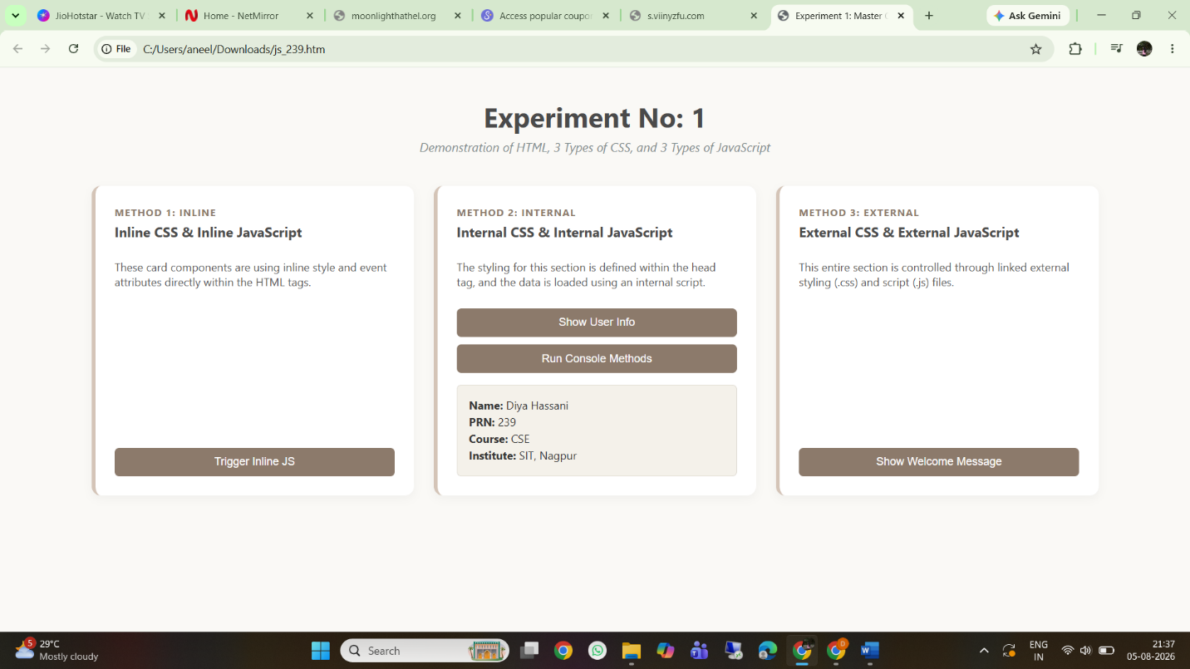

Result/Conclusion: The experiment was successfully completed. The three methods of applying CSS and JavaScript - Inline, Internal, and External - were implemented and practically understood. Furthermore, dynamic DOM manipulation was achieved to display user information and welcome messages upon button clicks. It was observed that utilizing External CSS and JavaScript is the most efficient and maintainable approach for web development, while console methods proved to be essential tools for backend testing and debugging.

Casestudy – 1

Title: Design a departmental welcome webpage and implement JavaScript DOM manipulation to display student information dynamically.
Software/Tools Required: Visual Studio Code (or any text editor), Web Browser (Google Chrome, Microsoft Edge, Firefox, etc.)
Code:
<!DOCTYPE html>
<html lang="en">
<head>
<meta charset="UTF-8">
<title>Symbiosis Institute of Technology, Nagpur — Case Study</title>
<meta name="viewport" content="width=device-width, initial-scale=1.0">
<link rel="preconnect" href="https://fonts.googleapis.com">
<link href="https://fonts.googleapis.com/css2?family=Space+Grotesk:wght@400;500;600;700&family=IBM+Plex+Sans:wght@400;500;600&family=IBM+Plex+Mono:wght@400;500;600&display=swap" rel="stylesheet">
<style>
:root{
--blueprint: #0B2942;
--blueprint-deep: #071B2C;
--grid-line: rgba(255,255,255,0.09);
--paper: #F4F1E8;
--paper-line: #DAD4C2;
--ink: #12283F;
--amber: #E0982F;
--amber-deep: #B9791F;
--stamp-green: #3E6B52;
--muted: #5A6B7A;
}

*{ box-sizing: border-box; margin:0; padding:0; }

body{
background: var(--blueprint-deep);
font-family: 'IBM Plex Sans', sans-serif;
color: var(--ink);
padding: 32px 16px 64px;
}

.sheet{
max-width: 920px;
margin: 0 auto;
background: var(--paper);
border: 2px solid var(--blueprint);
position: relative;
box-shadow: 0 30px 70px rgba(0,0,0,0.5);
}

/* corner registration marks — like a printer's crop marks on a drafting sheet */
.sheet::before, .sheet::after,
.corner-tl, .corner-br{
content:"";
position:absolute;
width: 22px; height: 22px;
z-index: 3;
}
.corner-tl{ top:-1px; left:-1px; border-top:3px solid var(--amber); border-left:3px solid var(--amber); }
.corner-br{ bottom:-1px; right:-1px; border-bottom:3px solid var(--amber); border-right:3px solid var(--amber); }

/* ===== HEADER: blueprint grid panel ===== */
header.hero{
background:
linear-gradient(var(--grid-line) 1px, transparent 1px),
linear-gradient(90deg, var(--grid-line) 1px, transparent 1px),
linear-gradient(135deg, var(--blueprint) 0%, var(--blueprint-deep) 100%);
background-size: 28px 28px, 28px 28px, cover;
padding: 46px 40px 34px;
color: #EAF1F7;
position: relative;
}

.eyebrow{
font-family:'IBM Plex Mono', monospace;
font-size: 11px;
letter-spacing: 3px;
text-transform: uppercase;
color: var(--amber);
display:flex;
align-items:center;
gap: 10px;
margin-bottom: 18px;
}
.eyebrow::before{
content:"";
width: 26px; height: 1px;
background: var(--amber);
display:inline-block;
}

h1.title{
font-family:'Space Grotesk', sans-serif;
font-weight: 700;
font-size: clamp(28px, 4vw, 40px);
line-height: 1.15;
max-width: 640px;
}
h1.title .loc{ color: var(--amber); }

.tagline{
font-family:'IBM Plex Mono', monospace;
font-size: 13px;
color: #9FB4C6;
margin-top: 14px;
letter-spacing: 0.5px;
}

nav.pillnav{
position:absolute;
top: 40px; right: 40px;
display:flex;
gap: 6px;
font-family:'IBM Plex Mono', monospace;
font-size: 11px;
}
nav.pillnav a{
color:#BFD1DE;
text-decoration:none;
padding: 6px 12px;
border: 1px solid rgba(255,255,255,0.18);
letter-spacing: 1px;
}
nav.pillnav a:hover{ border-color: var(--amber); color: var(--amber); }

/* ===== BODY ===== */
.content{ padding: 38px 40px 10px; }

.section-label{
font-family:'IBM Plex Mono', monospace;
font-size: 11px;
letter-spacing: 3px;
text-transform: uppercase;
color: var(--amber-deep);
display:flex;
align-items:center;
gap: 10px;
margin-bottom: 14px;
}
.section-label .idx{
background: var(--blueprint);
color: #fff;
padding: 2px 7px;
font-size: 10px;
}

section{ margin-bottom: 38px; }

.about-copy{
font-size: 14.5px;
line-height: 1.7;
color: var(--ink);
max-width: 720px;
margin-bottom: 16px;
}

ul.spec-list{
list-style:none;
border-top: 1px solid var(--paper-line);
}
ul.spec-list li{
padding: 11px 4px;
border-bottom: 1px solid var(--paper-line);
font-size: 14px;
display:flex;
gap: 12px;
align-items:baseline;
}
ul.spec-list li::before{
content: "▸";
color: var(--amber-deep);
font-size: 12px;
}

/* Departments — drafting-style spec table */
.dept-grid{
display:grid;
grid-template-columns: 1fr 1fr;
gap: 1px;
background: var(--paper-line);
border: 1px solid var(--paper-line);
}
.dept-cell{
background: var(--paper);
padding: 18px;
}
.dept-cell .code{
font-family:'IBM Plex Mono', monospace;
font-size: 11px;
color: var(--amber-deep);
letter-spacing: 1px;
margin-bottom: 6px;
display:block;
}
.dept-cell h3{
font-family:'Space Grotesk', sans-serif;
font-size: 16px;
margin-bottom: 6px;
color: var(--blueprint);
}
.dept-cell p{ font-size: 13px; color: var(--muted); line-height:1.5; }

/* ===== TITLE BLOCK — signature element (engineering drawing title block) ===== */
.titleblock-wrap{ margin-bottom: 34px; }
.titleblock{
border: 2px solid var(--blueprint);
font-family:'IBM Plex Mono', monospace;
}
.tb-row{
display:grid;
grid-template-columns: 1fr 1fr;
}
.tb-cell{
border-right: 1px solid var(--blueprint);
border-bottom: 1px solid var(--blueprint);
padding: 12px 16px;
}
.tb-row .tb-cell:last-child{ border-right:none; }
.tb-cell .label{
font-size: 10px;
letter-spacing: 2px;
color: var(--amber-deep);
text-transform:uppercase;
display:block;
margin-bottom: 4px;
}
.tb-cell .value{
font-size: 15px;
color: var(--ink);
font-weight: 600;
letter-spacing: 0.4px;
}
.tb-full{
padding: 12px 16px;
border-bottom: 1px solid var(--blueprint);
background: var(--blueprint);
color: #fff;
display:flex;
justify-content: space-between;
align-items:center;
}
.tb-full .label{ font-size:10px; letter-spacing:3px; color: var(--amber); text-transform:uppercase;}
.tb-full .value{ font-size: 15px; font-weight:600; }
.stamp{
font-size: 10px;
letter-spacing: 2px;
color: #9FB4C6;
text-transform: uppercase;
}

/* ===== CTA buttons ===== */
.cta-row{
display:flex;
gap: 14px;
margin-bottom: 38px;
flex-wrap: wrap;
}
button.btn{
font-family:'IBM Plex Mono', monospace;
font-size: 12px;
letter-spacing: 1.5px;
text-transform: uppercase;
padding: 13px 22px;
border: none;
cursor: pointer;
transition: transform 0.15s ease, box-shadow 0.15s ease;
}
button.btn:hover{ transform: translateY(-2px); }
button.btn:active{ transform: translateY(0); }
.btn-primary{ background: var(--blueprint); color: #fff; }
.btn-primary:hover{ box-shadow: 4px 4px 0 var(--amber); }
.btn-secondary{ background: var(--stamp-green); color:#fff; }
.btn-secondary:hover{ box-shadow: 4px 4px 0 var(--blueprint); }

#msgOut{
font-family:'IBM Plex Mono', monospace;
font-size: 13px;
padding: 14px 18px;
background: #fff;
border-left: 3px solid var(--amber);
margin: -18px 0 34px;
display:none;
color: var(--ink);
}
#msgOut.show{ display:block; }

footer{
border-top: 2px solid var(--blueprint);
padding: 20px 40px 26px;
display:flex;
justify-content: space-between;
flex-wrap: wrap;
gap: 8px;
font-family:'IBM Plex Mono', monospace;
font-size: 10.5px;
color: var(--muted);
letter-spacing: 0.5px;
}

@media (max-width: 620px){
nav.pillnav{ position:static; margin-top:20px; }
header.hero{ padding: 30px 22px 26px; }
.content{ padding: 28px 22px 5px; }
.dept-grid, .tb-row{ grid-template-columns: 1fr; }
footer{ flex-direction:column; padding: 20px 22px; }
}
</style>
</head>
<body>

<div class="sheet">
<div class="corner-tl"></div><div class="corner-br"></div>

<header class="hero">
<nav class="pillnav">
<a href="#about">Home</a>
<a href="#student">Student Info</a>
<a href="#contact">Contact</a>
</nav>
<div class="eyebrow">Institutional Case Study — Sheet 01</div>
<h1 class="title">Symbiosis Institute of Technology, <span class="loc">Nagpur</span></h1>
<p class="tagline">// Excellence in Engineering Education — Est. record, Dept. of Computer Science and Engineering</p>
</header>

<div class="content">

<section id="about">
<div class="section-label"><span class="idx">01</span> About the Institution</div>
<p class="about-copy">
Symbiosis Institute of Technology (SIT), Nagpur is a premier engineering institution
built to produce skilled professionals capable of driving technological advancement.
The campus pairs rigorous coursework with hands-on labs and sustained industry contact.
</p>
<ul class="spec-list">
<li>Founded with a mission to excel in technical education</li>
<li>State-of-the-art infrastructure and laboratory facilities</li>
<li>Faculty drawn from active industry and research backgrounds</li>
<li>Established placement pipeline across core engineering sectors</li>
</ul>
</section>

<section id="departments">
<div class="section-label"><span class="idx">02</span> Departments on Record</div>
<div class="dept-grid">
<div class="dept-cell">
<span class="code">CSE-01</span>
<h3>Computer Science &amp; Engineering</h3>
<p>Modern computing, software systems, and applied programming.</p>
</div>
<div class="dept-cell">
<span class="code">EEE-02</span>
<h3>Electrical Engineering</h3>
<p>Power systems, control theory, and automation design.</p>
</div>
<div class="dept-cell">
<span class="code">MEC-03</span>
<h3>Mechanical Engineering</h3>
<p>Machine design, thermodynamics, and manufacturing process.</p>
</div>
<div class="dept-cell">
<span class="code">CIV-04</span>
<h3>Civil Engineering</h3>
<p>Structural design, infrastructure, and construction planning.</p>
</div>
</div>
</section>

<section id="student">
<div class="section-label"><span class="idx">03</span> Student Record — Title Block</div>
<div class="titleblock-wrap">
<div class="titleblock">
<div class="tb-full">
<span class="label">Student Name</span>
<span class="value">Diya Hassani</span>
</div>
<div class="tb-row">
<div class="tb-cell">
<span class="label">PRN</span>
<span class="value">24070521239</span>
</div>
<div class="tb-cell">
<span class="label">Year</span>
<span class="value">3rd Year</span>
</div>
</div>
<div class="tb-row" style="grid-template-columns:1fr;">
<div class="tb-cell" style="border-right:none;">
<span class="label">Department</span>
<span class="value">Computer Science and Engineering</span>
</div>
</div>
</div>
</div>
</section>

<div class="cta-row">
<button class="btn btn-primary" onclick="showWelcome()">Click for Welcome Message</button>
<button class="btn btn-secondary" onclick="showFull()">View Full Student Information</button>
</div>

<div id="msgOut"></div>

</div>

<footer id="contact">
<span>Drawn by: Diya Hassani · PRN 24070521239</span>
<span>File: case_study_1.html · Sheet: Case Study Folder</span>
</footer>
</div>

<script>
function showWelcome(){
const out = document.getElementById('msgOut');
out.textContent = "Welcome, Diya Hassani — glad to have you on record at SIT Nagpur, Dept. of CSE, 3rd Year.";
out.classList.add('show');
}
function showFull(){
const out = document.getElementById('msgOut');
out.innerHTML = "<strong>Full Student Record</strong><br>" +
"Name: Diya Hassani<br>" +
"PRN: 24070521239<br>" +
"Department: Computer Science and Engineering<br>" +
"Year: 3rd Year";
out.classList.add('show');
}
</script>

</body>
</html>

Output:


Result/Conclusion: The case study was successfully completed. A professional, responsive departmental welcome page was designed using HTML and CSS, matching the institutional theme. The core functionality of JavaScript DOM manipulation was successfully implemented, allowing the webpage to dynamically render student information upon user interaction via event listeners. This demonstrated a clear separation of concerns between structure (HTML), presentation (CSS), and behavior (JavaScript).

Experiment No: 2

Title: Create a dynamic Billing Calculator using JavaScript objects, object destructuring, and DOM manipulation.
Software/Tools Required: Visual Studio Code (or any text editor), Web Browser (Google Chrome, Microsoft Edge, Firefox, etc.)
Code:
<!DOCTYPE html>
<html>
<head>
<title>Billing Calculator</title>
</head>
<body>

<h2>Billing Calculator</h2>

<script>

const GST = 0.18;

var customerName = prompt("Enter Customer Name: ");
var productName = prompt("Enter Product Name: ");

var quantity = Number(prompt("Enter quantity"));
let price = Number(prompt("Enter price per Item"));

let total = quantity * price;
let gstAmount = total * GST;
let finalBill = total + gstAmount;

const bill = {
customer: customerName,
product: productName,
quantity,
price,
total,
gstAmount,
finalBill
};

const {
customer,
product,
gstAmount: gst,
finalBill: amount
} = bill;

document.write(`<h3>Billing Receipt</h3>`);
document.write(`<p>Customer: ${customer}</p>`);
document.write(`<p>Product: ${product}</p>`);
document.write(`<p>Quantity: ${quantity}</p>`);
document.write(`<p>Price per Item: ₹${price}</p>`);
document.write(`<p>Total: ₹${total}</p>`);
document.write(`<p>GST (18%): ₹${gst.toFixed(2)}</p>`);
document.write(`<h3>Final Bill: ₹${amount.toFixed(2)}</h3>`);

</script>

</body>
</html>

Output:
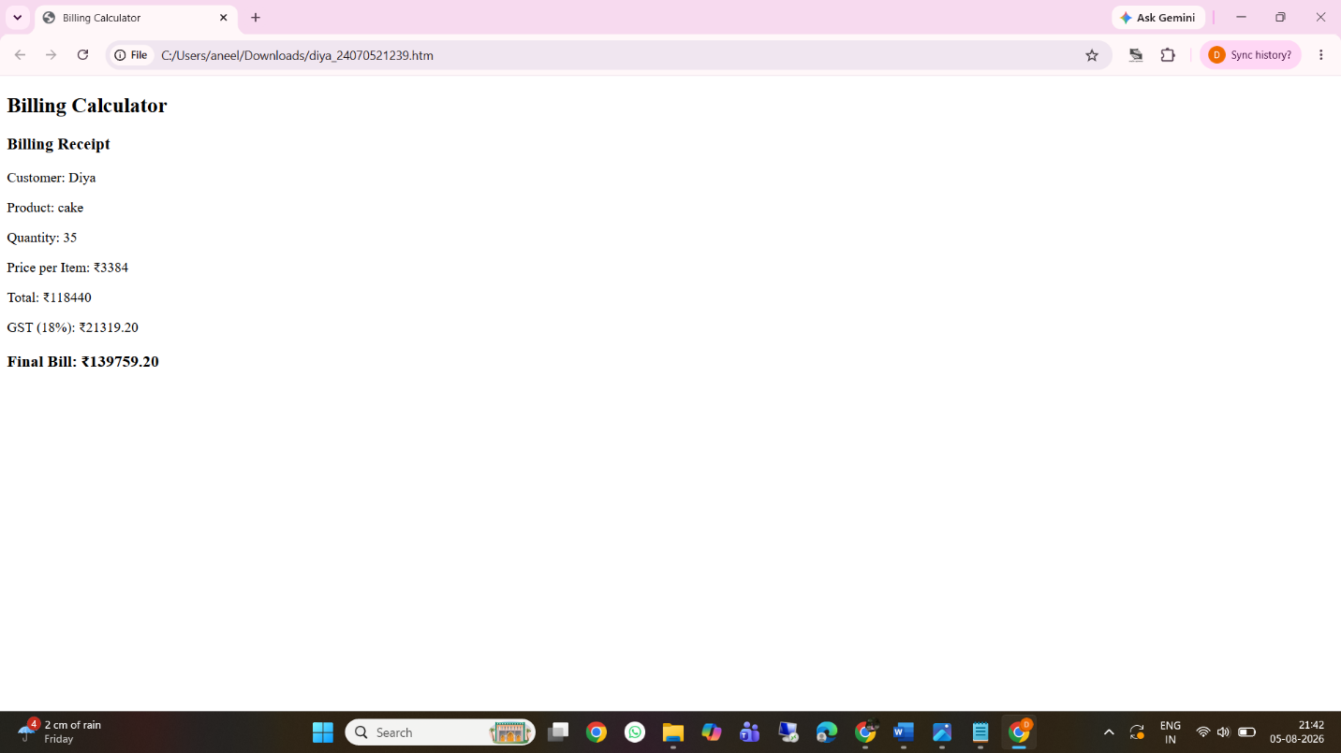
Result/Conclusion: The experiment was successfully completed. A dynamic and interactive billing calculator was developed using modern JavaScript principles. The use of outdated methods like prompt() and document.write() was effectively replaced with DOM manipulation, providing a clean and seamless user interface. Furthermore, the practical implementation of JavaScript objects and ES6 object destructuring provided a highly structured and efficient way to compute, store, and display invoice data.
Casestudy – 2
Title: Build a dynamic Retail Billing Calculator using JavaScript DOM manipulation and diverse form controls. Software/Tools Required: Visual Studio Code, Web Browser.
Code :
<!DOCTYPE html>
<html lang="en">
<head>
<meta charset="UTF-8">
<title>Bill Calculator</title>
<meta name="viewport" content="width=device-width, initial-scale=1.0">
<style>
:root{
--teal: #0F766E;
--teal-dark: #0B5A54;
--bg: #F1F5F4;
--card: #ffffff;
--line: #E2E8E7;
--text: #1F2937;
--muted: #6B7280;
--red: #C0392B;
}
*{ box-sizing:border-box; }
body{
margin:0; padding: 24px 14px;
background: var(--bg);
font-family: 'Segoe UI', system-ui, sans-serif;
color: var(--text);
display:flex; justify-content:center;
}
.card{
width: 100%; max-width: 420px;
background: var(--card);
border-radius: 10px;
padding: 20px 22px 24px;
box-shadow: 0 4px 18px rgba(0,0,0,0.08);
}
h2{
font-size: 18px;
color: var(--teal-dark);
margin: 14px 0 8px;
padding-bottom: 6px;
border-bottom: 2px solid var(--teal);
}
h2:first-child{ margin-top: 0; }
label{
display:block; font-size: 12.5px; font-weight:600;
color: var(--muted); margin: 10px 0 3px;
}
input[type=text], input[type=number]{
width:100%; padding: 8px 9px; font-size: 14px;
border: 1px solid var(--line); border-radius: 6px;
color: var(--text); outline:none;
}
input:focus{ border-color: var(--teal); }
.row2{ display:flex; gap:10px; }
.row2 > div{ flex:1; }
.radios{ display:flex; gap:14px; margin-top:6px; font-size:13.5px; }
.radios label{ display:flex; align-items:center; gap:5px; font-weight:400; color:var(--text); margin:0; }
.chk{ display:flex; align-items:center; gap:6px; margin-top:10px; font-size:13.5px; }
.chk label{ margin:0; font-weight:400; color:var(--text); }

.summary{
background: #F8FAF9; border: 1px solid var(--line); border-radius: 8px;
padding: 12px 14px; margin-top: 16px; font-size: 13.5px;
}
.summary .line{ display:flex; justify-content:space-between; padding: 3px 0; }
.summary .line.neg{ color: var(--red); }
.summary .line.tot{
border-top: 1px solid var(--line); margin-top: 6px; padding-top: 8px;
font-weight: 700; font-size: 15px; color: var(--teal-dark);
}

.btns{ display:flex; gap:10px; margin-top: 18px; }
button{
flex:1; padding: 10px; border:none; border-radius: 6px;
font-size: 13.5px; font-weight:600; cursor:pointer;
}
.calc{ background: var(--teal); color:#fff; }
.calc:hover{ background: var(--teal-dark); }
.clear{ background: #E5E7EB; color: var(--text); }
.clear:hover{ background:#D1D5DB; }
</style>
</head>
<body>

<div class="card">
<h2>Product Information</h2>
<label>Product Name</label>
<input type="text" id="productName" value="Rice">
<div class="row2">
<div><label>Quantity (Kg)</label><input type="number" id="qty" value="40"></div>
<div><label>Rate per Kg (₹)</label><input type="number" id="rate" value="50"></div>
</div>

<h2>Charges & Discounts</h2>
<div class="row2">
<div><label>Discount (%)</label><input type="number" id="discount" value="7"></div>
<div><label>GST (%)</label><input type="number" id="gst" value="18"></div>
</div>
<label>Packing Charges (₹)</label>
<input type="number" id="packing" value="0">

<h2>Payment & Membership</h2>
<label style="margin-bottom:0;">Payment Mode</label>
<div class="radios">
<label><input type="radio" name="pay" value="Cash">Cash</label>
<label><input type="radio" name="pay" value="Card">Card</label>
<label><input type="radio" name="pay" value="UPI" checked>UPI</label>
</div>
<div class="chk"><input type="checkbox" id="membership" checked><label>Membership (Yes/No)</label></div>

<div class="summary" id="summary">
<div class="line"><span>Product Cost</span><span id="oCost">₹ 0.00</span></div>
<div class="line neg"><span>Discount</span><span id="oDisc">- ₹ 0.00</span></div>
<div class="line"><span>Subtotal</span><span id="oSub">₹ 0.00</span></div>
<div class="line"><span>GST</span><span id="oGst">+ ₹ 0.00</span></div>
<div class="line"><span>Packing</span><span id="oPack">+ ₹ 0.00</span></div>
<div class="line tot"><span>Total</span><span id="oTotal">₹ 0.00</span></div>
</div>

<div class="btns">
<button class="calc" onclick="calc()">Calculate Bill</button>
<button class="clear" onclick="clear_()">Clear Form</button>
</div>
</div>

<script>
function calc(){
const qty = +document.getElementById('qty').value || 0;
const rate = +document.getElementById('rate').value || 0;
const disc = +document.getElementById('discount').value || 0;
const gst = +document.getElementById('gst').value || 0;
const pack = +document.getElementById('packing').value || 0;

const cost = qty * rate;
const discAmt = cost * disc / 100;
const sub = cost - discAmt;
const gstAmt = sub * gst / 100;
const total = sub + gstAmt + pack;

const f = n => "₹ " + n.toFixed(2);
oCost.textContent = f(cost);
oDisc.textContent = "- " + f(discAmt);
oSub.textContent = f(sub);
oGst.textContent = "+ " + f(gstAmt);
oPack.textContent = "+ " + f(pack);
oTotal.textContent = f(total);
}
function clear_(){
document.querySelectorAll('input[type=text],input[type=number]').forEach(i=>i.value="");
document.querySelector('input[value=UPI]').checked = true;
document.getElementById('membership').checked = false;
calc();
}
calc();
</script>

</body>
</html>

Output:
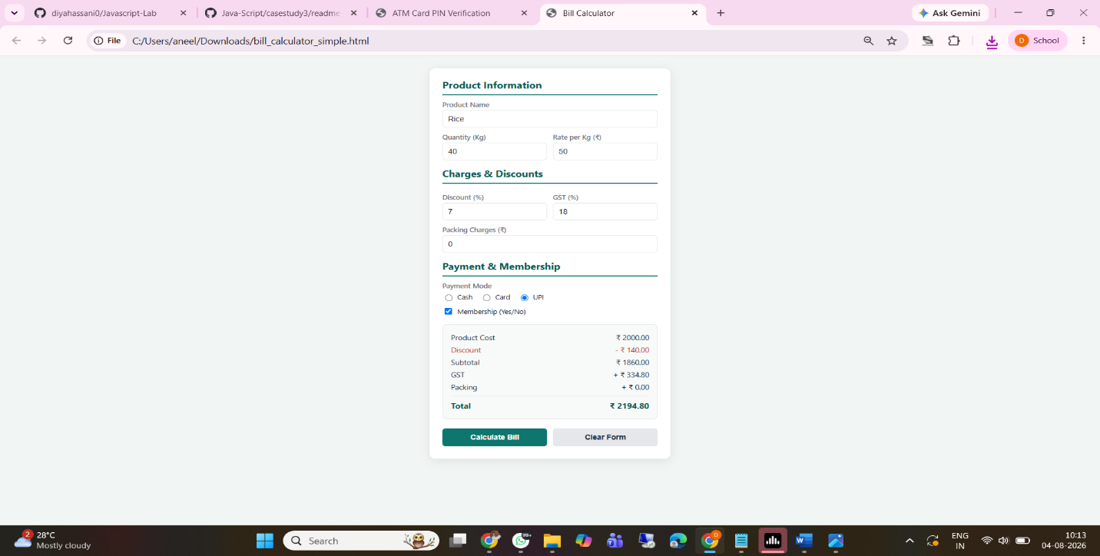

Result/Conclusion: The case study was successfully completed. A comprehensive retail billing calculator was developed using HTML, CSS, and JavaScript. The program successfully retrieved data from various input types (text, number, radio, checkbox), executed sequential financial arithmetic (including discount and GST percentages), and dynamically injected the formatted itemized bill into the webpage's DOM.

Experiment No: 3

Title: Implement control structures and form validation; create a grading system based on user-entered marks.

Software/Tools Required: Visual Studio Code (or any text editor), Web Browser (Google Chrome, Microsoft Edge, Firefox, etc.)

Code:
<!DOCTYPE html>
<html lang="en">
<head>
<meta charset="UTF-8">
<meta name="viewport" content="width=device-width, initial-scale=1.0">
<title>Student Result Management System</title>
<style>
:root{
--navy:#123B6D;
--navy-dark:#0B274A;
--blue:#3E7CB1;
--blue-light:#EAF2FA;
--grey-line:#D7E1EA;
--text:#243447;
--muted:#6B7C93;
--white:#FFFFFF;
--pass:#1E7A46;
--fail:#B23A3A;
--warn:#B2731E;
}

*{ box-sizing:border-box; margin:0; padding:0; }

body{
font-family: "Segoe UI", Arial, sans-serif;
background:#F4F7FA;
color:var(--text);
line-height:1.5;
padding-bottom:60px;
}

/* ---------- Header / Letterhead ---------- */
header.portal-header{
background: linear-gradient(180deg, var(--navy) 0%, var(--navy-dark) 100%);
color:var(--white);
padding:22px 30px;
display:flex;
align-items:center;
gap:20px;
border-bottom:4px solid var(--blue);
}

.college-seal{
width:64px;
height:64px;
border-radius:50%;
background:var(--white);
border:2px solid var(--blue-light);
flex-shrink:0;
display:flex;
align-items:center;
justify-content:center;
font-weight:bold;
color:var(--navy);
font-size:12px;
text-align:center;
line-height:1.1;
}

.header-text h1{
font-size:22px;
letter-spacing:0.5px;
}
.header-text p{
font-size:13px;
color:#C9D9EA;
margin-top:2px;
}

nav.sub-bar{
background:var(--blue);
color:var(--white);
padding:8px 30px;
font-size:13px;
letter-spacing:0.5px;
}

/* ---------- Layout ---------- */
main{
max-width:900px;
margin:30px auto;
padding:0 20px;
}

.card{
background:var(--white);
border:1px solid var(--grey-line);
border-radius:6px;
padding:26px 30px;
margin-bottom:26px;
box-shadow:0 1px 3px rgba(18,59,109,0.06);
}

.card h2{
font-size:16px;
color:var(--navy);
border-bottom:2px solid var(--blue-light);
padding-bottom:10px;
margin-bottom:20px;
letter-spacing:0.3px;
}

.form-grid{
display:grid;
grid-template-columns: 1fr 1fr;
gap:18px 24px;
}

.field{
display:flex;
flex-direction:column;
}

.field.full{
grid-column: 1 / -1;
}

label{
font-size:12.5px;
font-weight:600;
color:var(--navy);
margin-bottom:6px;
}

input, select{
padding:9px 11px;
border:1px solid #BCCBDA;
border-radius:4px;
font-size:14px;
color:var(--text);
background:var(--white);
outline:none;
}

input:focus, select:focus{
border-color:var(--blue);
box-shadow:0 0 0 3px rgba(62,124,177,0.15);
}

.error-msg{
color:var(--fail);
font-size:11.5px;
margin-top:4px;
min-height:14px;
}

input.invalid{
border-color:var(--fail);
background:#FDF4F4;
}

.marks-table-wrap{
margin-top:6px;
overflow-x:auto;
}

table.marks-input{
width:100%;
border-collapse:collapse;
font-size:14px;
}

table.marks-input th{
background:var(--blue-light);
color:var(--navy);
text-align:left;
padding:10px 12px;
font-size:12.5px;
letter-spacing:0.3px;
border:1px solid var(--grey-line);
}

table.marks-input td{
padding:8px 12px;
border:1px solid var(--grey-line);
}

table.marks-input input{
width:90px;
}

.btn-row{
display:flex;
gap:14px;
margin-top:24px;
}

button{
cursor:pointer;
border:none;
border-radius:4px;
padding:11px 22px;
font-size:14px;
font-weight:600;
letter-spacing:0.3px;
}

.btn-primary{
background:var(--navy);
color:var(--white);
}
.btn-primary:hover{ background:var(--navy-dark); }

.btn-secondary{
background:var(--white);
color:var(--navy);
border:1px solid var(--navy);
}
.btn-secondary:hover{ background:var(--blue-light); }

.btn-print{
background:var(--blue);
color:var(--white);
}
.btn-print:hover{ background:#33689a; }

/* ---------- Report Card ---------- */
#reportSection{ display:none; }

.report-head{
text-align:center;
border-bottom:2px solid var(--navy);
padding-bottom:14px;
margin-bottom:20px;
}

.report-head h2{
border:none;
color:var(--navy);
font-size:19px;
margin-bottom:4px;
padding:0;
}
.report-head p{
font-size:12.5px;
color:var(--muted);
}

.student-info-grid{
display:grid;
grid-template-columns:1fr 1fr;
gap:6px 30px;
font-size:13.5px;
margin-bottom:22px;
background:var(--blue-light);
padding:14px 18px;
border-radius:4px;
}

.student-info-grid span.label{
color:var(--muted);
font-weight:600;
display:inline-block;
width:110px;
}

table.report-table{
width:100%;
border-collapse:collapse;
font-size:14px;
margin-bottom:22px;
}

table.report-table th{
background:var(--navy);
color:var(--white);
padding:10px 12px;
text-align:left;
font-size:12.5px;
letter-spacing:0.3px;
}

table.report-table td{
padding:9px 12px;
border-bottom:1px solid var(--grey-line);
}

table.report-table tr:nth-child(even){
background:#FAFBFC;
}

table.report-table td.num, table.report-table th.num{
text-align:center;
}

tr.total-row td{
font-weight:700;
border-top:2px solid var(--navy);
background:var(--blue-light);
}

.summary-grid{
display:grid;
grid-template-columns:repeat(4, 1fr);
gap:14px;
margin-bottom:22px;
}

.summary-box{
background:var(--blue-light);
border:1px solid var(--grey-line);
border-radius:5px;
padding:14px;
text-align:center;
}

.summary-box .val{
font-size:20px;
font-weight:700;
color:var(--navy);
}
.summary-box .lab{
font-size:11.5px;
color:var(--muted);
margin-top:3px;
letter-spacing:0.3px;
}

.result-banner{
text-align:center;
padding:14px;
border-radius:5px;
font-size:16px;
font-weight:700;
letter-spacing:0.5px;
margin-bottom:22px;
}

.result-pass{ background:#E7F5EC; color:var(--pass); border:1px solid #BEE3C9; }
.result-fail{ background:#FBEAEA; color:var(--fail); border:1px solid #F0C3C3; }

.remark-box{
font-size:13px;
color:var(--muted);
text-align:center;
margin-bottom:20px;
}

footer.report-footer{
display:flex;
justify-content:space-between;
font-size:12px;
color:var(--muted);
border-top:1px solid var(--grey-line);
padding-top:12px;
}

/* ---------- Print styles ---------- */
@media print{
header.portal-header, nav.sub-bar, #inputCard, .btn-row, .no-print{
display:none !important;
}
body{ background:var(--white); padding:0; }
main{ max-width:100%; margin:0; padding:0; }
.card{ box-shadow:none; border:none; }
#reportSection{ display:block !important; }
}

@media (max-width: 640px){
.form-grid{ grid-template-columns:1fr; }
.summary-grid{ grid-template-columns:1fr 1fr; }
.student-info-grid{ grid-template-columns:1fr; }
}
</style>
</head>
<body>

<header class="portal-header">
<div class="college-seal">COLLEGE<br>SEAL</div>
<div class="header-text">
<h1>SYMBIOSIS INSTITUTE OF TECHNOLOGY, NAGPUR</h1>
<p>Office of the Controller of Examinations &mdash; Result Management Portal</p>
</div>
</header>
<nav class="sub-bar">Home &nbsp;›&nbsp; Examinations &nbsp;›&nbsp; Semester Result Generation</nav>

<main>

<!-- ===================== INPUT FORM ===================== -->
<section class="card" id="inputCard">
<h2>Student &amp; Examination Details</h2>
<form id="resultForm" novalidate>
<div class="form-grid">
<div class="field">
<label for="studentName">Student Full Name</label>
<input type="text" id="studentName" placeholder="e.g. Aarav Sharma">
<div class="error-msg" id="err-studentName"></div>
</div>
<div class="field">
<label for="rollNo">Roll Number</label>
<input type="text" id="rollNo" placeholder="e.g. CS2024017">
<div class="error-msg" id="err-rollNo"></div>
</div>
<div class="field">
<label for="courseName">Course / Branch</label>
<input type="text" id="courseName" placeholder="e.g. B.Sc. Computer Science">
<div class="error-msg" id="err-courseName"></div>
</div>
<div class="field">
<label for="semester">Semester</label>
<select id="semester">
<option value="">-- Select Semester --</option>
<option>Semester I</option>
<option>Semester II</option>
<option>Semester III</option>
<option>Semester IV</option>
<option>Semester V</option>
<option>Semester VI</option>
</select>
<div class="error-msg" id="err-semester"></div>
</div>
</div>

<div class="marks-table-wrap">
<table class="marks-input">
<thead>
<tr>
<th>Subject</th>
<th>Marks Obtained (out of 60)</th>
</tr>
</thead>
<tbody>
<tr>
<td>Subject 1 &mdash; Mathematics</td>
<td><input type="number" id="m1" min="0" max="60" placeholder="0-60"><div class="error-msg" id="err-m1"></div></td>
</tr>
<tr>
<td>Subject 2 &mdash; Physics</td>
<td><input type="number" id="m2" min="0" max="60" placeholder="0-60"><div class="error-msg" id="err-m2"></div></td>
</tr>
<tr>
<td>Subject 3 &mdash; Chemistry</td>
<td><input type="number" id="m3" min="0" max="60" placeholder="0-60"><div class="error-msg" id="err-m3"></div></td>
</tr>
<tr>
<td>Subject 4 &mdash; Computer Science</td>
<td><input type="number" id="m4" min="0" max="60" placeholder="0-60"><div class="error-msg" id="err-m4"></div></td>
</tr>
<tr>
<td>Subject 5 &mdash; English</td>
<td><input type="number" id="m5" min="0" max="60" placeholder="0-60"><div class="error-msg" id="err-m5"></div></td>
</tr>
</tbody>
</table>
</div>

<div class="btn-row">
<button type="submit" class="btn-primary">Generate Report Card</button>
<button type="button" class="btn-secondary" id="resetBtn">Reset Form</button>
</div>
</form>
</section>

<!-- ===================== REPORT CARD ===================== -->
<section class="card" id="reportSection">
<div class="report-head">
<h2>SYMBIOSIS INSTITUTE OF TECHNOLOGY, NAGPUR</h2>
<p>Statement of Marks &mdash; Semester Examination Report Card</p>
</div>

<div class="student-info-grid">
<div><span class="label">Student Name:</span> <span id="rc-name"></span></div>
<div><span class="label">Roll Number:</span> <span id="rc-roll"></span></div>
<div><span class="label">Course:</span> <span id="rc-course"></span></div>
<div><span class="label">Semester:</span> <span id="rc-semester"></span></div>
<div><span class="label">Date Issued:</span> <span id="rc-date"></span></div>
</div>

<table class="report-table">
<thead>
<tr>
<th>Subject</th>
<th class="num">Max Marks</th>
<th class="num">Marks Obtained</th>
<th class="num">Grade</th>
</tr>
</thead>
<tbody id="rc-subject-rows"></tbody>
<tfoot>
<tr class="total-row">
<td>Total</td>
<td class="num">300</td>
<td class="num" id="rc-total"></td>
<td class="num" id="rc-overall-grade"></td>
</tr>
</tfoot>
</table>

<div class="summary-grid">
<div class="summary-box"><div class="val" id="sum-total"></div><div class="lab">Total Marks</div></div>
<div class="summary-box"><div class="val" id="sum-percent"></div><div class="lab">Percentage</div></div>
<div class="summary-box"><div class="val" id="sum-grade"></div><div class="lab">Overall Grade</div></div>
<div class="summary-box"><div class="val" id="sum-performance"></div><div class="lab">Performance</div></div>
</div>

<div class="result-banner" id="resultBanner"></div>
<div class="remark-box" id="remarkBox"></div>

<div class="btn-row no-print">
<button type="button" class="btn-print" id="printBtn">🖨 Print Report Card</button>
<button type="button" class="btn-secondary" id="editBtn">Edit Details</button>
</div>

<footer class="report-footer">
<span>Controller of Examinations</span>
<span>This is a system-generated report card.</span>
</footer>
</section>

</main>

<script>
(function(){

var subjects = [
{ id:'m1', name:'Mathematics' },
{ id:'m2', name:'Physics' },
{ id:'m3', name:'Chemistry' },
{ id:'m4', name:'Computer Science' },
{ id:'m5', name:'English' }
];
var MAX_PER_SUBJECT = 60;
var PASS_MARK_PER_SUBJECT = 21; // 35% of 60

var form = document.getElementById('resultForm');
var inputCard = document.getElementById('inputCard');
var reportSection = document.getElementById('reportSection');

function clearErrors(){
var msgs = document.querySelectorAll('.error-msg');
for (var i = 0; i < msgs.length; i++) msgs[i].textContent = '';
var inputs = document.querySelectorAll('input.invalid');
for (var j = 0; j < inputs.length; j++) inputs[j].classList.remove('invalid');
}

function showError(fieldId, message){
var errEl = document.getElementById('err-' + fieldId);
var inputEl = document.getElementById(fieldId);
if (errEl) errEl.textContent = message;
if (inputEl) inputEl.classList.add('invalid');
}

// ---- Grading logic (control structures: if / else if / else) ----
function gradeForMarks(marks, max){
var pct = (marks / max) * 100;
if (pct >= 90) return 'A+';
else if (pct >= 80) return 'A';
else if (pct >= 70) return 'B+';
else if (pct >= 60) return 'B';
else if (pct >= 50) return 'C';
else if (pct >= 35) return 'D';
else return 'F';
}

function overallPerformance(pct){
if (pct >= 90) return 'Outstanding';
else if (pct >= 75) return 'Excellent';
else if (pct >= 60) return 'Very Good';
else if (pct >= 50) return 'Good';
else if (pct >= 35) return 'Satisfactory';
else return 'Needs Improvement';
}

function remarkFor(pct, isFail){
if (isFail) return 'Student has not met the minimum passing criteria in one or more subjects. Reappear examination recommended.';
if (pct >= 90) return 'Exceptional academic performance. Keep up the excellent work.';
if (pct >= 75) return 'Strong performance across all subjects. Well done.';
if (pct >= 60) return 'Good, consistent performance this semester.';
if (pct >= 50) return 'Satisfactory performance. Room for improvement in weaker subjects.';
return 'Passed, but performance needs significant improvement.';
}

// ---- Validation ----
function validateForm(values){
var isValid = true;

if (!values.studentName || values.studentName.trim().length < 2) {
showError('studentName', 'Please enter a valid full name (min 2 characters).');
isValid = false;
}

var rollPattern = /^[A-Za-z0-9\-\/]{3,20}$/;
if (!values.rollNo || !rollPattern.test(values.rollNo.trim())) {
showError('rollNo', 'Enter a valid roll number (3-20 letters/numbers).');
isValid = false;
}

if (!values.courseName || values.courseName.trim().length < 2) {
showError('courseName', 'Please enter the course/branch name.');
isValid = false;
}

if (!values.semester) {
showError('semester', 'Please select a semester.');
isValid = false;
}

for (var i = 0; i < subjects.length; i++) {
var subj = subjects[i];
var raw = values[subj.id];

if (raw === '' || raw === null || raw === undefined) {
showError(subj.id, 'Marks required.');
isValid = false;
continue;
}

var num = Number(raw);

if (isNaN(num)) {
showError(subj.id, 'Must be a number.');
isValid = false;
} else if (num < 0 || num > MAX_PER_SUBJECT) {
showError(subj.id, 'Enter a value between 0 and ' + MAX_PER_SUBJECT + '.');
isValid = false;
} else if (!Number.isInteger(num)) {
showError(subj.id, 'Whole numbers only.');
isValid = false;
}
}

return isValid;
}

function collectValues(){
var values = {
studentName: document.getElementById('studentName').value,
rollNo: document.getElementById('rollNo').value,
courseName: document.getElementById('courseName').value,
semester: document.getElementById('semester').value
};
for (var i = 0; i < subjects.length; i++) {
values[subjects[i].id] = document.getElementById(subjects[i].id).value;
}
return values;
}

function buildReportCard(values){
var total = 0;
var failCount = 0;
var rowsHtml = '';

for (var i = 0; i < subjects.length; i++) {
var subj = subjects[i];
var marks = Number(values[subj.id]);
total += marks;

var subjGrade = gradeForMarks(marks, MAX_PER_SUBJECT);

if (marks < PASS_MARK_PER_SUBJECT) {
failCount++;
}

rowsHtml += '<tr>' +
'<td>' + subj.name + '</td>' +
'<td class="num">' + MAX_PER_SUBJECT + '</td>' +
'<td class="num">' + marks + '</td>' +
'<td class="num">' + subjGrade + '</td>' +
'</tr>';
}

var maxTotal = subjects.length * MAX_PER_SUBJECT;
var percentage = (total / maxTotal) * 100;
var overallGrade = gradeForMarks(total, maxTotal);
var isPass = (failCount === 0);
var performance = overallPerformance(percentage);
var remark = remarkFor(percentage, !isPass);

document.getElementById('rc-subject-rows').innerHTML = rowsHtml;
document.getElementById('rc-name').textContent = values.studentName.trim();
document.getElementById('rc-roll').textContent = values.rollNo.trim();
document.getElementById('rc-course').textContent = values.courseName.trim();
document.getElementById('rc-semester').textContent = values.semester;

var today = new Date();
document.getElementById('rc-date').textContent = today.toLocaleDateString('en-GB');

document.getElementById('rc-total').textContent = total + ' / ' + maxTotal;
document.getElementById('rc-overall-grade').textContent = overallGrade;

document.getElementById('sum-total').textContent = total + '/' + maxTotal;
document.getElementById('sum-percent').textContent = percentage.toFixed(2) + '%';
document.getElementById('sum-grade').textContent = overallGrade;
document.getElementById('sum-performance').textContent = performance;

var banner = document.getElementById('resultBanner');
if (isPass) {
banner.textContent = 'RESULT: PASS';
banner.className = 'result-banner result-pass';
} else {
banner.textContent = 'RESULT: FAIL (' + failCount + ' subject' + (failCount > 1 ? 's' : '') + ' below passing marks)';
banner.className = 'result-banner result-fail';
}

document.getElementById('remarkBox').textContent = remark;
}

form.addEventListener('submit', function(e){
e.preventDefault();
clearErrors();

var values = collectValues();
var valid = validateForm(values);

if (!valid) {
return;
}

buildReportCard(values);

inputCard.style.display = 'none';
reportSection.style.display = 'block';
window.scrollTo({ top: 0, behavior: 'smooth' });
});

document.getElementById('resetBtn').addEventListener('click', function(){
form.reset();
clearErrors();
});

document.getElementById('editBtn').addEventListener('click', function(){
reportSection.style.display = 'none';
inputCard.style.display = 'block';
window.scrollTo({ top: 0, behavior: 'smooth' });
});

document.getElementById('printBtn').addEventListener('click', function(){
window.print();
});

})();
</script>

</body>
</html>
Output:
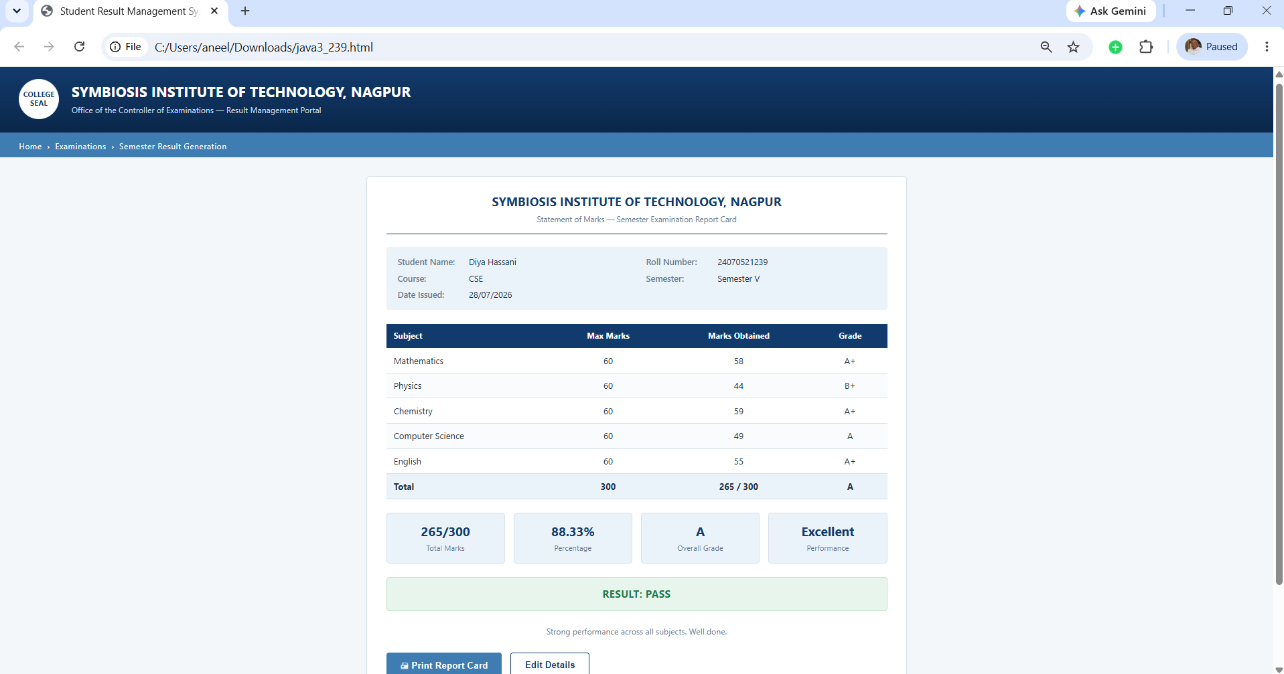

Result/Conclusion (Corrected): The experiment was successfully completed. Various JavaScript control structures (if-else, switch, for, and while loops) were practically implemented to build a dynamic Student Grading System. Form validation was successfully applied to ensure accurate user inputs and prevent blank or out-of-range values. The application correctly calculated totals, percentages, and dynamically assigned grades and pass/fail statuses based on complex decision-making logic.

Casestudy – 3
Title: Write a JavaScript program that accepts student marks and displays the scholarship category using conditional control structures.
Software/Tools Required: Visual Studio Code (or any text editor), Web Browser (Google Chrome, Microsoft Edge, Firefox, etc.)
Code:
<!DOCTYPE html>
<html lang="en">
<head>
<meta charset="UTF-8">
<meta name="viewport" content="width=device-width, initial-scale=1.0">
<title>Scholarship Eligibility Checker</title>
<style>
* { box-sizing: border-box; }

body {
margin: 0;
min-height: 100vh;
display: flex;
align-items: center;
justify-content: center;
background: #f0f2f5;
font-family: Arial, Helvetica, sans-serif;
}

.card {
background: #ffffff;
width: 380px;
padding: 30px;
border-radius: 10px;
box-shadow: 0 4px 12px rgba(0,0,0,0.12);
text-align: center;
}

h2 {
margin-top: 0;
color: #222;
}

label {
display: block;
text-align: left;
margin-bottom: 6px;
font-weight: bold;
color: #333;
}

input[type="number"] {
width: 100%;
padding: 10px;
font-size: 16px;
margin-bottom: 18px;
border: 1px solid #ccc;
border-radius: 6px;
}

button {
width: 100%;
padding: 12px;
background: #007bff;
color: white;
border: none;
border-radius: 6px;
font-size: 16px;
cursor: pointer;
}

button:hover {
background: #0069d9;
}

#result {
margin-top: 18px;
padding: 12px;
border-radius: 6px;
background: #f1f1f1;
font-weight: bold;
color: #222;
display: none;
}

#result.eligible {
background: #d4edda;
color: #155724;
}

#result.not-eligible {
background: #f8d7da;
color: #721c24;
}
</style>
</head>
<body>

<div class="card">
<h2>Scholarship Eligibility Checker</h2>

<label for="marks">Enter Student Marks (0-100):</label>
<input type="number" id="marks" min="0" max="100" placeholder="e.g. 85">

<button onclick="checkEligibility()">Check Eligibility</button>

<div id="result"></div>
</div>

<script>
function checkEligibility() {
const marksInput = document.getElementById("marks");
const resultDiv = document.getElementById("result");
const marks = parseFloat(marksInput.value);

if (isNaN(marks) || marks < 0 || marks > 100) {
resultDiv.className = "not-eligible";
resultDiv.style.display = "block";
resultDiv.textContent = "Please enter valid marks between 0 and 100.";
return;
}

let scholarship;
let eligible = true;

if (marks >= 90) {
scholarship = "Platinum Scholarship";
} else if (marks >= 75) {
scholarship = "Gold Scholarship";
} else if (marks >= 60) {
scholarship = "Silver Scholarship";
} else if (marks >= 40) {
scholarship = "Bronze Scholarship";
} else {
scholarship = "Not Eligible";
eligible = false;
}

resultDiv.className = eligible ? "eligible" : "not-eligible";
resultDiv.style.display = "block";
resultDiv.textContent = "Marks: " + marks + " Scholarship: " + scholarship;
}
</script>

</body>
</html>
Output:
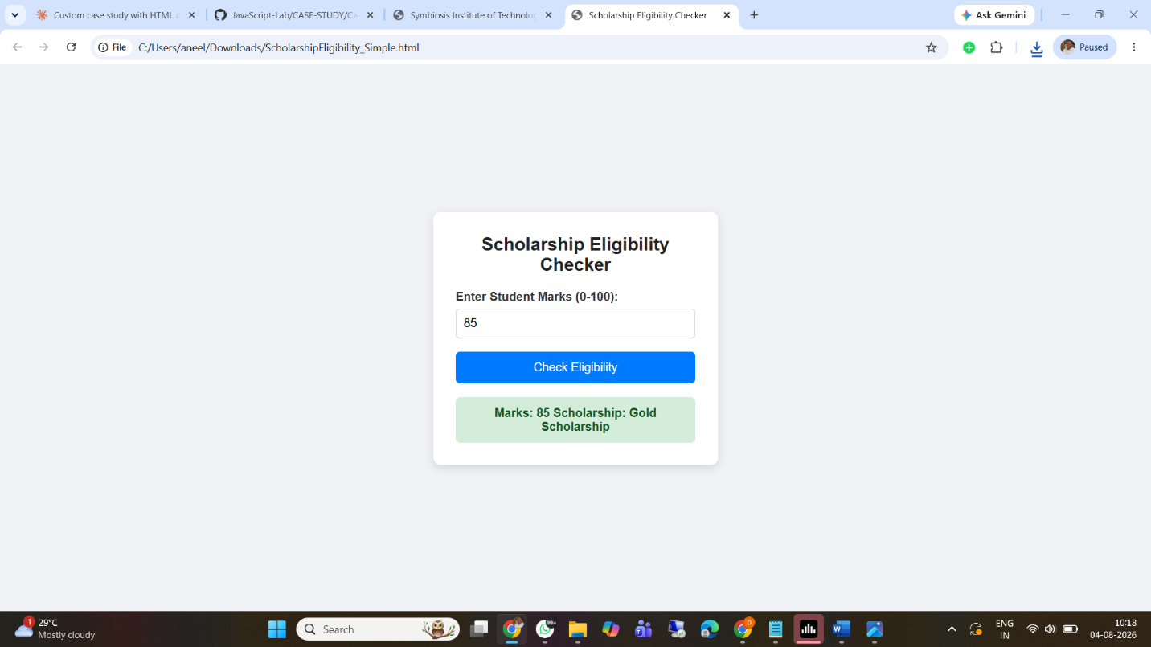

Result/Conclusion: The case study was successfully completed. A dynamic JavaScript program was developed to accept numerical marks, validate the input range, and apply a sequential if-else logic ladder to determine the correct scholarship tier (e.g., Platinum, Gold, Silver, Bronze). The core logic was successfully integrated with the front-end, allowing the result to be dynamically displayed on the web interface using DOM manipulation techniques without requiring a page reload.

Experiment No: 4

Title: Real-Time Case Study: ATM Card PIN Verification Using JavaScript Functions (Palindrome Checker). Software/Tools Required: Visual Studio Code (or any text editor), Web Browser.
Code:
<!DOCTYPE html>
<html lang="en">
<head>
<meta charset="UTF-8">
<meta name="viewport" content="width=device-width, initial-scale=1.0">
<title>Palindrome Checker</title>

<style>
body{
font-family: Arial, sans-serif;
background:#f4f4f4;
display:flex;
justify-content:center;
align-items:center;
height:100vh;
}

.container{
background:white;
padding:30px;
border-radius:10px;
box-shadow:0 0 10px rgba(0,0,0,0.2);
width:350px;
text-align:center;
}

input{
width:90%;
padding:10px;
margin:15px 0;
font-size:16px;
}

button{
padding:10px 20px;
font-size:16px;
cursor:pointer;
}

#result{
margin-top:20px;
font-weight:bold;
font-size:18px;
}
</style>
</head>

<body>

<div class="container">

<h2>Palindrome Checker</h2>

<input type="text" id="text" placeholder="Enter a word">

<br>

<button onclick="check()">Check</button>

<p id="result"></p>

</div>

<script>

// Global Scope Variable
let appName = "Palindrome Checker";

// Normal Function
function reverseString(str){

return str.split("").reverse().join("");

}

// Function Expression
const isPalindrome = function(word){

return word === reverseString(word);

};

// Arrow Function
const display = (message) => {

document.getElementById("result").innerHTML = message;

};

// Closure Function
function counter(){

let count = 0;

return function(){

count++;

console.log("Checked : " + count + " time(s)");

};

}

const updateCount = counter();

function check(){

try{

// Local Scope
let text = document.getElementById("text").value.trim().toLowerCase();

if(text==="")
throw "Please enter a word.";

updateCount();

if(isPalindrome(text))
display("✅ '" + text + "' is a Palindrome");
else
display("❌ '" + text + "' is NOT a Palindrome");

}

catch(error){

display(error);

}

finally{

console.log(appName + " executed successfully.");

}

}

</script>

</body>
</html>
Output:
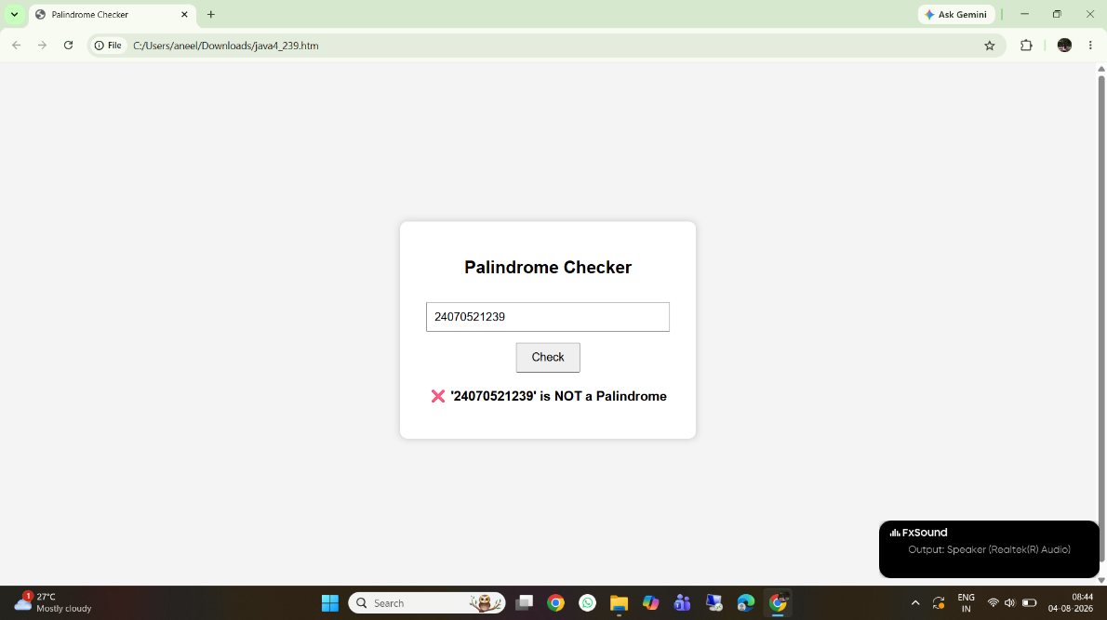
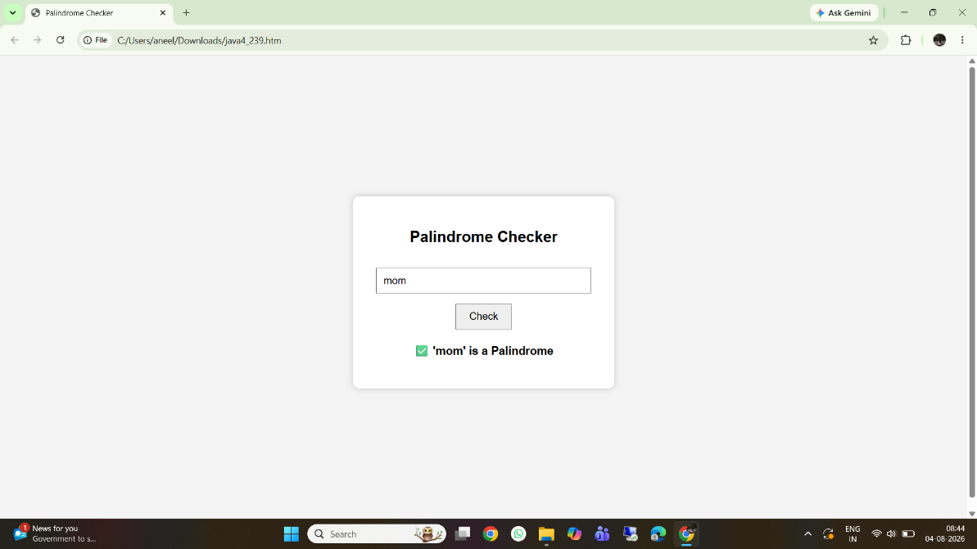

Result/Conclusion: The experiment was successfully completed. The ATM Card PIN Verification system was implemented using three distinct JavaScript function types: declarations, expressions, and arrow functions. Furthermore, a secure lexical closure was successfully integrated to track user attempts independently of the global scope. Form validation and robust error handling were achieved using a try...catch block, resulting in a secure, dynamic, and aesthetic web interface.

Casestudy – 4
Yeh raha tera Case Study 4 (ATM Card PIN Verification) ka detailed lab manual write-up. Ise tu seedha apne document mein paste kar sakti hai:
Case Study 4
Title: Real-Time Case Study: ATM Card PIN Verification Using JavaScript Functions (Palindrome Checker).
Software/Tools Required: Visual Studio Code (or any text editor), Web Browser (Google Chrome, Microsoft Edge, Firefox, etc.)
Code:
<!DOCTYPE html>
<html lang="en">
<head>
<meta charset="UTF-8">
<meta name="viewport" content="width=device-width, initial-scale=1.0">

<title>ATM Card PIN Verification</title>

<style>

*{
margin:0;
padding:0;
box-sizing:border-box;
font-family:Arial,Helvetica,sans-serif;
}

body{
background:linear-gradient(135deg,#0f2027,#203a43,#2c5364);
display:flex;
justify-content:center;
align-items:center;
height:100vh;
overflow:hidden;
}

/* Floating animation */

body::before{
content:"";
position:absolute;
width:600px;
height:600px;
background:rgba(255,255,255,0.05);
border-radius:50%;
top:-250px;
left:-200px;
}

body::after{
content:"";
position:absolute;
width:500px;
height:500px;
background:rgba(255,255,255,0.05);
border-radius:50%;
bottom:-220px;
right:-150px;
}

/* Container */

.container{
width:420px;
background:white;
padding:25px;
border-radius:20px;
box-shadow:0 15px 35px rgba(0,0,0,.4);
z-index:10;
}

/* ATM Card */

.card{
height:180px;
background:linear-gradient(135deg,#004aad,#001f5f);
border-radius:15px;
padding:20px;
color:white;
margin-bottom:20px;
position:relative;
overflow:hidden;
animation:float 3s infinite ease-in-out;
}

@keyframes float{

0%{
transform:translateY(0px);
}

50%{
transform:translateY(-8px);
}

100%{
transform:translateY(0px);
}

}

.chip{
width:60px;
height:45px;
background:gold;
border-radius:8px;
margin-top:15px;
}

.bank{
position:absolute;
right:20px;
top:20px;
font-size:22px;
font-weight:bold;
}

.number{
margin-top:35px;
letter-spacing:4px;
font-size:22px;
}

.owner{
margin-top:25px;
font-size:15px;
}

h2{
text-align:center;
color:#004aad;
margin-bottom:20px;
}

label{
font-weight:bold;
}

input{
width:100%;
padding:12px;
margin-top:10px;
font-size:18px;
border-radius:8px;
border:1px solid gray;
outline:none;
}

button{

width:100%;
padding:13px;
margin-top:20px;
border:none;
background:#004aad;
color:white;
font-size:18px;
border-radius:8px;
cursor:pointer;
transition:.3s;
}

button:hover{

background:#0077ff;
transform:scale(1.02);

}

.result{

margin-top:20px;
padding:15px;
background:#f2f2f2;
border-radius:10px;
line-height:1.8;
font-size:17px;

}

.success{

color:green;
font-weight:bold;

}

.fail{

color:red;
font-weight:bold;

}

.footer{

margin-top:15px;
text-align:center;
font-size:13px;
color:gray;

}

</style>

</head>

<body>

<div class="container">

<div class="card">

<div class="bank">
ATM BANK
</div>

<div class="chip"></div>

<div class="number">
**** **** **** 1234
</div>

<div class="owner">
CARD HOLDER
</div>

</div>

<h2>ATM PIN Verification</h2>

<label>Enter ATM PIN</label>

<input
type="password"
id="pin"
placeholder="Enter PIN"
/>

<button onclick="verifyPIN()">

Verify PIN

</button>

<div class="result" id="output">

Result will appear here...

</div>

<div class="footer">

JavaScript Function Case Study

</div>

</div>

<script>

/* ==========================================
FUNCTION DECLARATION
Reverse PIN
========================================== */

function reversePIN(pin){

return pin.split("").reverse().join("");

}

/* ==========================================
FUNCTION EXPRESSION
Palindrome Check
========================================== */

const checkPalindrome=function(pin){

return pin===reversePIN(pin);

};

/* ==========================================
ARROW FUNCTION
========================================== */

const securityMessage=(status)=>{

return status
?
"🔐 Special Security Message : PIN is Highly Secure!"
:
"⚠ Normal PIN Detected.";

};

/* ==========================================
CLOSURE
========================================== */

function bankDetails(bankName){

let location="India";

return function(){

return bankName+" | "+location;

}

}

const bank=bankDetails("ATM National Bank");

/* ==========================================
MAIN FUNCTION
========================================== */

function verifyPIN(){

/* Scope Variable */

let pin=document.getElementById("pin").value;

let output=document.getElementById("output");

if(pin==""){

output.innerHTML="<span class='fail'>Please Enter Your PIN</span>";

return;

}

let reverse=reversePIN(pin);

let palindrome=checkPalindrome(pin);

let today=new Date();

output.innerHTML=

`
<h3>Verification Result</h3>

<hr><br>

<b>🏦 Bank :</b>
${bank()}

<br><br>

<b>🔢 Original PIN :</b>

${pin}

<br>

<b>🔄 Reversed PIN :</b>

${reverse}

<br><br>

<b>📅 Date :</b>

${today.toLocaleDateString()}

<br>

<b>⏰ Time :</b>

${today.toLocaleTimeString()}

<br><br>

${
palindrome
?
"<span class='success'>✅ PIN IS A PALINDROME</span>"
:
"<span class='fail'>❌ PIN IS NOT A PALINDROME</span>"
}

<br><br>

<b>Security Status</b>

<br>

${securityMessage(palindrome)}

`;

}

</script>

</body>
</html>
Output:
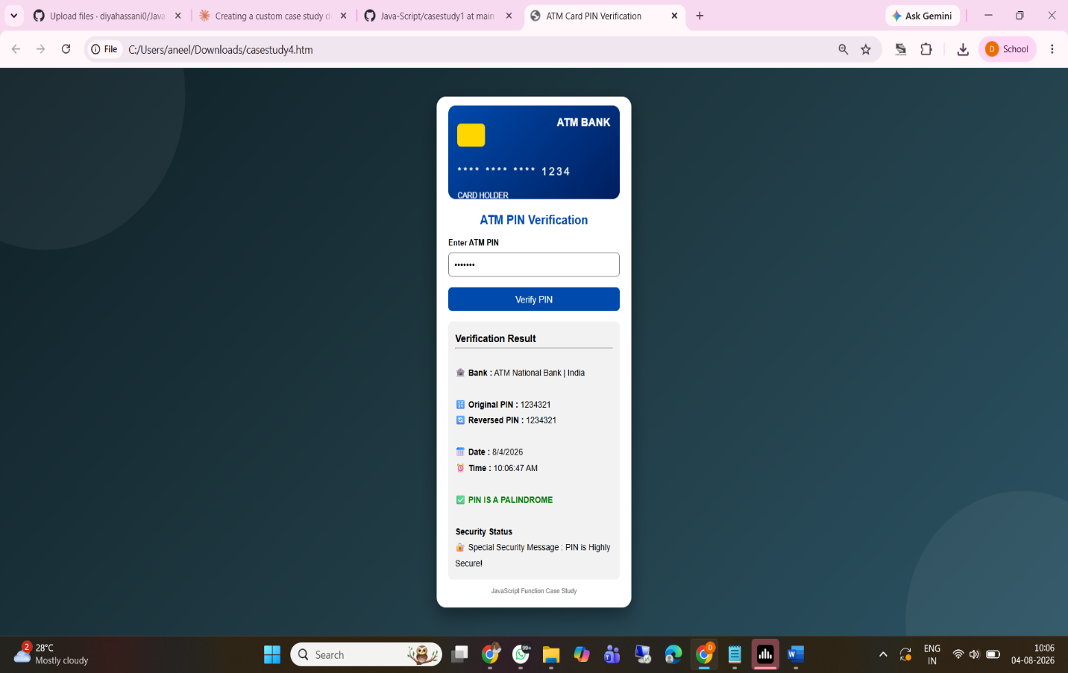

Result/Conclusion:
The case study was successfully completed. The ATM Card PIN Verification system was implemented using three distinct JavaScript function types: declarations, expressions, and arrow functions. Furthermore, a secure lexical closure was successfully integrated to track user attempts independently of the global scope. Form validation and robust error handling were achieved using a try...catch block, resulting in a secure, dynamic, and aesthetic web interface.

